What is Logistic Regression?
Logistic regression is the appropriate regression analysis to conduct when the dependent variable is dichotomous (binary). logistic regression is a predictive analysis. It is used to describe data and to explain the relationship between one dependent binary variable and one or more nominal, ordinal, interval or ratio-level independent variables.
Logistic Regression is another statistical analysis method borrowed by Machine Learning.
It is used when our dependent variable is dichotomous or binary. It just means a variable that has only 2 outputs, for example, A person will survive this accident or not, The student will pass this exam or not.
The outcome can either be yes or no (2 outputs).
Logistic regression technique is similar to linear regression and can be used to predict the Probabilities for classification problems.

Types of Logistic Regression
There are the three main types of logistic regression:

Binary logistic regression
Binary logistic regression is used to predict the probability of a binary outcome, such as yes or no, true or false, or 0 or 1.
For example, it could be used to predict whether a customer will churn or not, whether a patient has a disease or not, or whether a loan will be repaid or not.

Multinomial logistic regression
Multinomial logistic regression is used to predict the probability of one of three or more possible outcomes, such as the type of product a customer will buy, the rating a customer will give a product, or the political party a person will vote for.

Ordinal logistic regression
is used to predict the probability of an outcome that falls into a predetermined order, such as the level of customer satisfaction, the severity of a disease, or the stage of cancer.

Why use Logistic Regression rather than Linear Regression?

logistic regression is only used when our dependent variable is binary and in linear regression dependent variable is continuous.
The second problem is that if we add an outlier in our dataset, the best fit line in linear regression shifts to fit that point.
Now, if we use linear regression to find the best fit line which aims at minimizing the distance between the predicted value and actual value, the line will be like this:
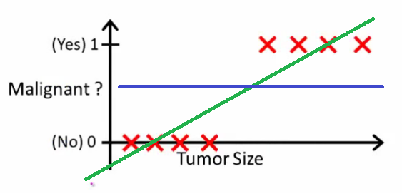
Here the threshold value is 0.5, which means if the value of h(x) is greater than 0.5 then we predict malignant tumor (1) and if it is less than 0.5 then we predict benign tumor (0).
now we add some outliers in our dataset, now this best fit line will shift to that point. Hence the line will be somewhat like this:
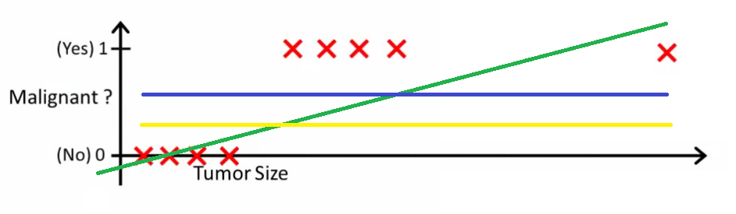
Now see the problem, The blue line represents the old threshold and the yellow line represents the new threshold which is maybe 0.2 here.
To keep our predictions right we had to lower our threshold value.
Hence we can say that linear regression is prone to outliers.
Now here if h(x) is greater than 0.2 then only this regression will give correct outputs.
Another problem with linear regression is that the predicted values may be out of range. We know that probability can be between 0 and 1, but if we use linear regression this probability may exceed 1 or go below 0.
To overcome these problems we use Logistic Regression, which converts this straight best fit line in linear regression to an S-curve using the sigmoid function, which will always give values between 0 and 1.

